For the opposition there is a very big gap in the defence which may allow this player to make the run.

Although the possession is on the far side of the pitch, this has created lots of space on this side of the pitch, enough space for another player to run towards for a cross and be unmarked.

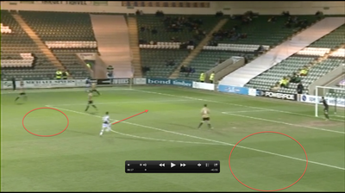

Alternatively the same player could drop into this space to create an angle for a pass.

This player should be further up the pitch approximately another 5 yards before he is offside as there are 2 opposition players between him and the ball.

This is footage from Plymouth Argyle V Newport County in a League 2 fixture. It is a snapshot of part of the game where I feel coaching is needed as well as analysis.