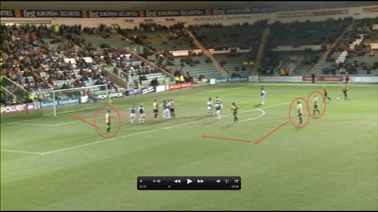

The player pointed by the arrow could use the free space marked to run into and shoot

The ball may not be played into the box, instead it could be played across the outside of the box to the two other players on the outside. The defenders do not seem to be tight enough in defending these players and they could have a quick long shot.

This player should be marking the player on this nearside

The players have left the player at the near side of the pitch unmarked, with the correct ball from the free kick, he could easily score or set another player up.